The Broadcaster ▪ August 5, 2020 ▪ 715-432-6285 ▪ stoneyacrescsa@gmail.com ▪ www.stoneyacresfarm.net
“I have no hostility to nature, but a child's love to it. I expand and live in the warm day like corn and melons.”
--Ralph Waldo Emerson

News from the Farm
CSA Week 10, 2020! There is so much to report this week! In vegetable-related news, a mass garlic harvest came in this week and we will be putting garlic in your box for five times down the stretch. Field tomatoes are about three weeks away from bulk harvesting! As always, CSA members can come and pick a half-bushel of field tomatoes as part of their share. If you put in a home delivery order for a bushel ($50), I will bring it right to your house. We are having so much fun with the kittens! They are already paying their dues as farm animals. I set them out at pizza night and they created a hysterical cuteness storm with three-year-old girls. You’re welcome to come out for a pizza and a snuggle on Friday or Saturday (we’re going to have great live music this weekend). It’s been a good hay year, and that combined with the demand for local organic grass fed beef prompted me to buy seven more yearling cows. The bull is VERY interested. I spent some time yesterday with the chopper, getting straw for oyster mushrooms! That’s my version of farm nostalgia! The kids are thriving in the freedom and long days of the summer! Maple went from being a beginner bike rider to speeding down Rangeline road and keeping up with her big brothers. Riley is going to make sure that there are no fish remaining in a 10 mile radius. Ted has been my right hand man in our zucchini harvest.
--Have a delicious week- Tony, Riley, Ted, & Maple
In Your Box
Peppers
Leeks
Hungarian hot wax peppers Cabbage
Basil
Sweet corn
Cucumbers
Zucchini

Next Week’s Best Guess: Onions Carrots Potatoes Sweet corn Sage Zucchini Cucumbers Cilantro
Pizza specials of the Vegginald Vel-Johnson- Fennel, zucchini, broccoli, onions. Ben Franklin Soaking Food – Stoney sausage, peppers, caramelized onions, ajued oyster mushrooms. Blue Oyster Cult – Carr valley blue cheese, stoney sausage, ajued oyster mushrooms, garlic sauce Charred Chard – Flecked ham, roasted cherry tomatoes, roasted fennel, charred chard. Scapegoat—Goat cheese from laclare farm, garlic scape pesto, flecked ham, and roasted garlic scapes in post. Holy Shitake—Sausage, shitake mushrooms, roasted fennel, parm form harmony dairy in post. . Margherita—Fresh basil, heirloom tomatoes, fresh mozz, and basil pesto
Farm to Table Recipes Gleaned by Tony and Katie
Zucchini Gallette (From Smitten Kitchen): Serves 6
For the pastry: 1 1/4 cups all-purpose flour, chilled in the freezer for 30 minutes, 1/4 teaspoon salt, 8 tablespoons (1 stick) cold unsalted butter, cut into pieces and chill again ,1/4 cup sour cream, 2 teaspoons fresh lemon juice, 1/4 cup ice water
Filling: 1 large or 2 small zucchinis, sliced into 1/4 inch thick rounds, 1 tablespoon plus 1 teaspoon olive oil, 1 medium garlic clove, minced (about 1 teaspoon), 1/2 cup ricotta cheese, 1/2 cup (about 1 ounce) grated Parmesan cheese, 1/4 cup (1 ounce) shredded mozzarella, 1 tablespoon slivered basil leaves
Glaze:
1 egg yolk beaten with 1 teaspoon water
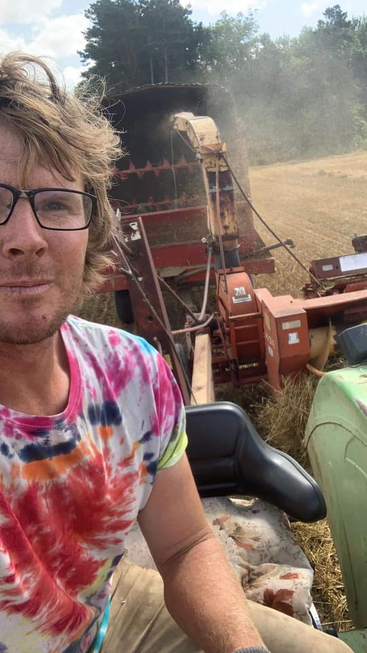
Make dough: Whisk together the flour and salt in a large bowl. Sprinkle bits of butter over dough and using a pastry blender, cut it in until the mixture resembles coarse meal, with the biggest pieces of butter the size of tiny peas. In a small bowl, whisk together the sour cream, lemon juice and water and add this to the butter-flour mixture. With your fingertips or a wooden spoon, mix in the liquid until large lumps form. Pat the lumps into a ball; do not overwork the dough. Cover with plastic wrap and refrigerate for 1 hour.
Make filling: Spread the zucchini out over several layers of paper towels. Sprinkle with 1/2 teaspoon salt and let drain for 30 minutes; gently blot the tops of the zucchini dry with paper towels before using. In a small bowl, whisk the olive oil and the garlic together; set aside. In a separate bowl, mix the ricotta, Parmesan, mozzarella, and 1 teaspoon of the garlicky olive oil together and season with salt and pepper to taste.
Prepare galette: Preheat oven to 400 degrees. On a floured work surface, roll the dough out into a 12-inch round. Transfer to an ungreased baking sheet (though if you line it with parchment paper, it will be easier to transfer it to a plate later). Spread the ricotta mixture evenly over the bottom of the galette dough, leaving a 2-inch border. Shingle the zucchini attractively on top of the ricotta in concentric circles, starting at the outside edge. Drizzle the remaining tablespoon of the garlic and olive oil mixture evenly over the zucchini. Fold the border over the filling, pleating the edge to make it fit. The center will be open. Brush crust with egg yolk glaze.
Bake the galette until the cheese is puffed, the zucchini is slightly wilted and the galette is golden brown, 30 to 40 minutes. Remove from the oven, sprinkle with basil, let stand for 5 minutes, then slide the galette onto a serving plate. Cut into wedges and serve hot, warm or at room temperature.
Corn Salsa
- 3 cups raw corn kernels* (from about 4 cobs of shucked sweet corn)
- 1 cup finely chopped red onion (about ½ medium onion)
- Optional: 1 diced ripe avocado
- ½ cup finely chopped fresh cilantro (about 1 bunch)
- 1 to 2 medium jalapeños, finely chopped (use 1 for mild-to-medium salsa or 2 for more spicy salsa)
- ¼ cup lime juice (about 2 limes), to taste
- 1 tablespoon white wine vinegar
- ¼ teaspoon chili powder
- ¼ teaspoon ground cumin
- ½ teaspoon fine sea salt
- In a medium serving bowl, combine all of the ingredients. Stir to combine.
- Adjust to taste, if necessary: For more zing, add about 1 teaspoon more vinegar or 1 tablespoon more lime juice. For more flavor overall, add another pinch of salt. For more spice, add more jalapeño.
- For best flavor, allow the salsa to marinate for 20 minutes before serving. This salsa keeps well in the refrigerator, covered, for 3 to 4 days.

