The Broadcaster ▪ August 26, 2020 ▪ 715-432-6285 ▪ stoneyacrescsa@gmail.com ▪ www.stoneyacresfarm.net
“Home grown tomatoes, home grown tomatoes
What would life be like without homegrown tomatoes
Only two things that money can't buy
That's true love and home grown tomatoes.”
--John Denver
News from the Farm
CSA Week 13, 2020! This is the newsletter where I brag about how awesome our farm is: as we move into the last week of August, the harvest is BOOMING! Cucumbers and zucchini just keep producing, and the cherry tomatoes are prolific this summer! This has been the best corn year that we have ever had! We are sharing a recipe (ripped from the headlines of Heather Busig’s facebook page) that features corn! I was telling Katie that I walked into the pepper house the other day and there was just so much red! We have a rainbow of peppers! With the beginning of the harvest explosion comes the end of the kids’ summer. Riley, Ted, and Maple will go off to school next week, after having a summer full of swimming, fishing, bike-riding, basketball, and LOTS of kitten time! Even though there is a lot to do on the farm, we made time to shoot a video for Bok Joy for Stoney Acres Brewery! If you happen to own stock in green body paint, feel free to thank me later! Alex Radtke, farm-hand extraordinaire, will be leaving to go to Seminary at the end of the month. Alex has been an incredible worker for the farm; he goes above and beyond in the farm tasks. He even wakes up at 5 AM to help me load up the truck on Saturdays! Riley has loved having an avid fisher-person to wet lines with; we will miss him and wish him all the best as he moves forward with his education!
--Have a delicious week- Tony, Riley, Ted, & Maple
In Your Box
Tomatoes
Cherry tomatoes Cucumbers
Zucchini (fulls)
Peppers
Dill
Broccoli
Beets
Carrots (fulls)
Leeks
Sweet corn

Next Week’s Best Guess: Cucs, zucs, peppers, corn, onions, tomatoes, cilantro, potato, garlic, cherry tomatoes
Pizza specials of the Vegginald Vel-Johnson- Fennel, zucchini, broccoli, onions. Ben Franklin Soaking Food – Stoney sausage, peppers, caramelized onions, ajued oyster mushrooms. Blue Oyster Cult – Carr valley blue cheese, stoney sausage, ajued oyster mushrooms, garlic sauce Sweet Honey n’ the Bock – Bacon, chevre, heirloom tomatoes, honey, and fresh ground pepper. Scapegoat—Goat cheese from laclare farm, garlic scape pesto, flecked ham, and roasted garlic scapes in post. Pizza Poblano tomatillo sauce Roasted poblano peppers, onions, sweet corn, chorizo sausage Margherita—Fresh basil, heirloom tomatoes, fresh mozz, and basil pesto
Farm to Table Recipes Gleaned by Tony and Katie (and usually Heather Busig)
Corn, Bacon, and Parmesan Pasta (From Smitten Kitchen)
- 8 ounces dried pasta (I used spirals here and radiatore in the past)
- 1/4 pound bacon, ideally thick-cut, diced
- 2 ears corn, shucked and kernels cut from cob
- Salt and freshly ground black pepper or red pepper flakes
- 3 scallions, thinly sliced
- 1/3 cup finely grated parmesan
- Fistful of fresh basil and chives, chopped
If you’re hoping to pull this all off in one pan, cook your pasta in a large deep saute pan* until al dente, or 1 to 2 minutes before it is done. Reserve a cup of pasta cooking water and drain. Wipe pan dry if using for the next steps, otherwise, you can get started in a large frying pan.
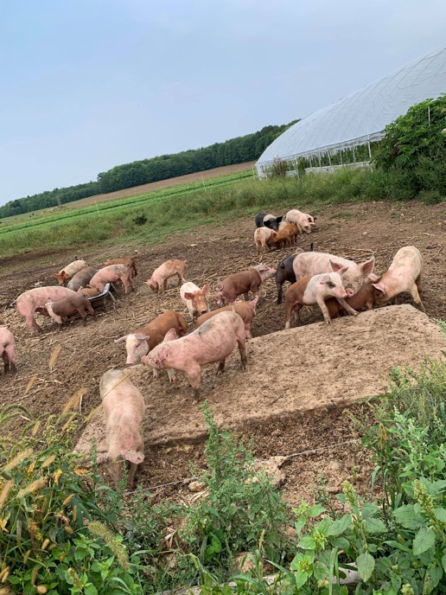
Scatter bacon in pan over medium-high heat, no need to heat the pan first. Cook, stirring, until evenly browned and crisp. Use a slotted spoon to transfer bacon bits to paper towels to drain. Pour off all but 1 tablespoon bacon fat from pan (save for other fun stuff, like frying eggs) and add corn to it. Season corn with salt and pepper and cook, stirring for 1 to 2 minutes, until crisp-tender. Add pasta and a couple splashes of the cooking water and half the parmesan and toss, toss, toss the pasta with the corn, seasoning with more salt and pepper if needed and adding more cooking water if it doesn’t feel loose enough. Add scallions and stir to warm. Stir in bacon and transfer to a serving bowl. Sprinkle with remaining cheese and fresh herbs. Dig in.
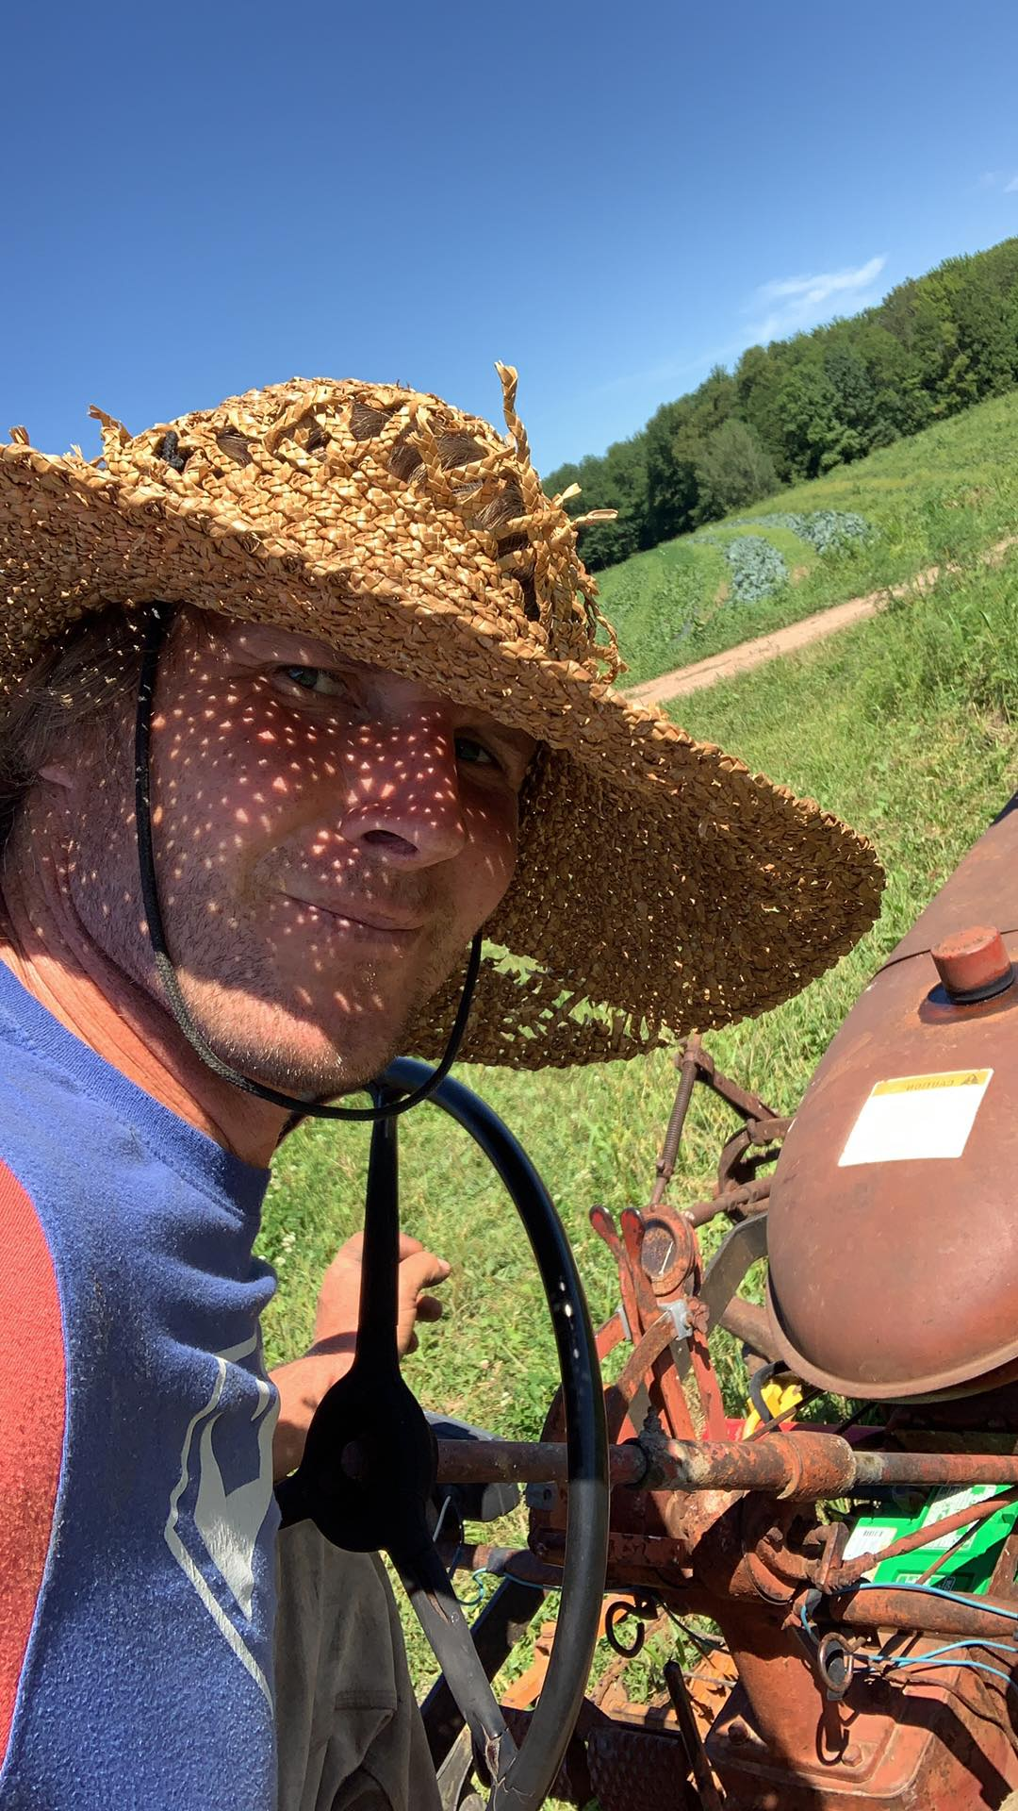
Vegetable Fritters (From Just a Taste)
INGREDIENTS
- 2 cups shredded zucchini
- 2 cups shredded carrots
- 2 cloves garlic, minced
- 2/3 cup all-purpose flour
- 2 large eggs, lightly beaten
- 1/3 cup sliced scallions (green and white parts)
- 2 Tablespoons olive oil
- Sour cream or yogurt, for serving
INSTRUCTIONS
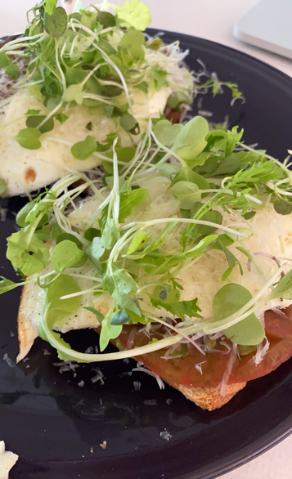
Place the shredded zucchini in a colander and sprinkle it lightly with salt. Let the zucchini sit for 10 minutes then using your hands, squeeze out as much liquid as possible. Transfer the zucchini to a large bowl then add the carrots, garlic, flour, eggs, scallions, 1/4 teaspoon salt and 1/8 teaspoon pepper. Stir the mixture until it is combined. Line a plate with paper towels. Place a large sauté pan over medium-high heat and add the olive oil. Once the oil is shimmering, scoop 3-tablespoon mounds of the vegetable mixture into the pan, flattening the mounds slightly and spacing them at least 1 inch apart. Cook the fritters for 2 to 3 minutes then flip them once and continue cooking them an additional 1 to 2 minutes until they’re golden brown and crispy. Transfer the fritters to the paper towel-lined plate, season them with salt and repeat the cooking process with the remaining mixture. Serve the fritters immediately topped with sour cream or yogurt

