The Broadcaster ▪ September 9, 2020 ▪ 715-432-6285 ▪ stoneyacrescsa@gmail.com ▪ www.stoneyacresfarm.net
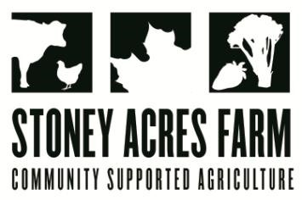
“If you can mock a leek, you can eat a leek!”
― William Shakespeare, Henry V

News from the Farm
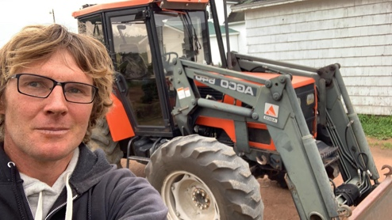
CSA Week 15, 2020! I was talking with my friend and farm-hand Stin and he was asking me why I planted so many leeks. It’s true, leeks are a little fussy in that they require cleaning, but their subtle, allium flavor makes them well worth the effort. I made potato leek soup this week for my crew, and I hope you make soup or a gratin recipe, or something else that you can enjoy in our chilly fall weather! In addition to leeks, we have been harvesting bushel upon bushel of tomatoes. The pepper house is still bursting, and the cooler weather has me looking forward to frost-sweetened brussel sprouts and kale, though I hope that temps that low hold off a while. I have been fortunate this year to be able to make some really strategic investments in the farm. I ordered an additional hoop house, which I am looking forward to putting up—I want to plant it full of spinach before our season ends! I also got a new tractor. Well, it’s the newest tractor I’ve ever had (it’s 25). I don’t usually put pictures in the news from the farm, but look at this beauty! And the tractor looks good, too!
--Have a delicious week- Tony, Riley, Ted, & Maple

In Your Box
Tomatoes
Celery
Peppers
Leeks
Bok Choy/Napa
Cabbage(Fulls)
Basil
Carrots
Lettuce

Next Week’s Best Guess: Tomatoes, peppers, leeks, bok choy, napa cabbage, cabbage, basil
Pizza specials of the Vegginald Vel-Johnson- Fennel, zucchini, broccoli, onions. Ben Franklin Soaking Food – Stoney sausage, peppers, caramelized onions, ajued oyster mushrooms. Blue Oyster Cult – Carr valley blue cheese, stoney sausage, ajued oyster mushrooms, garlic sauce Sweet Honey n’ the Bock – Bacon, chevre, heirloom tomatoes, honey, and fresh ground pepper. Scapegoat—Goat cheese from laclare farm, garlic scape pesto, flecked ham, and roasted garlic scapes in post. Charlie Behrens brats, sauerkraut, cheese curds Margherita—Fresh basil, heirloom tomatoes, fresh mozz, and basil pesto
Farm to Table Recipes Gleaned by Tony and Katie (and usually Heather Busig)
Potato Leek Soup (From Skinny Taste)
HOW TO CLEAN LEEKS: The most important thing to know about making this soup is how to clean the leeks. They’re sandy and dirty, and hide it pretty well, so be sure to wash them well. 1. First step is cutting off and discarding the root ends and thick dark green parts.2. Then cut the leeks in half lengthwise and rinse each half under cold water, pulling apart the layers to remove any grit that’s tucked inside. Once clean, you can proceed to chop them.
INGREDIENTS 4 medium leeks, dark green stems removed. 1/2 large white onion, chopped. 2 medium russet potatoes, peeled and cut into cubes, 1 tablespoon flour, use AP gluten free flour for GF, 1 tbsp butter, 4 cups chicken stock, use vegetable broth for vegetarians, 1/2 cup 2% milk, salt and fresh pepper
INSTRUCTIONSCoarsely chop leeks when washed. In a medium soup pot, melt butter and add flour on low flame. Using a wooden spoon, mix well. This will thicken your soup and give it a wonderful flavor. Add chicken stock, leeks, onion, potatoes and bring to a boil. Cover and simmer on low for about 20-25 minutes, until potatoes are soft.
Using an immersion blender, blend the soup until smooth adding the milk and adjusting salt and pepper to taste

Cow Jokes
For your Reading Pleasure
When cows get sick what do you call it? Hay Fever
Why did the cow jump over the moon? To get to the Milky Way
Why don’t cows have money? Because farmers milk them dry
What do you call a cow in an earthquake? A Milkshake
What do you call a cow with no ears? Call her all you want, she won’t hear you
Why do cows were bells? Their horns don’t work
What do you call cows with a sense of humor? Laughing stock
Why don’t cows understand what you say? Because it goes in one ear and out the udder
How did the farmer find his lost cow? He tractor down
Where do baby cows get their food? The cafeteria
What is the most important use for cowhide? Holding the cow together
What do you call a cow with two legs? Lean Beef
What do you call a cow with no legs? Ground Beef
What do you call a cow that won’t give milk? An udder failure or a milk dud
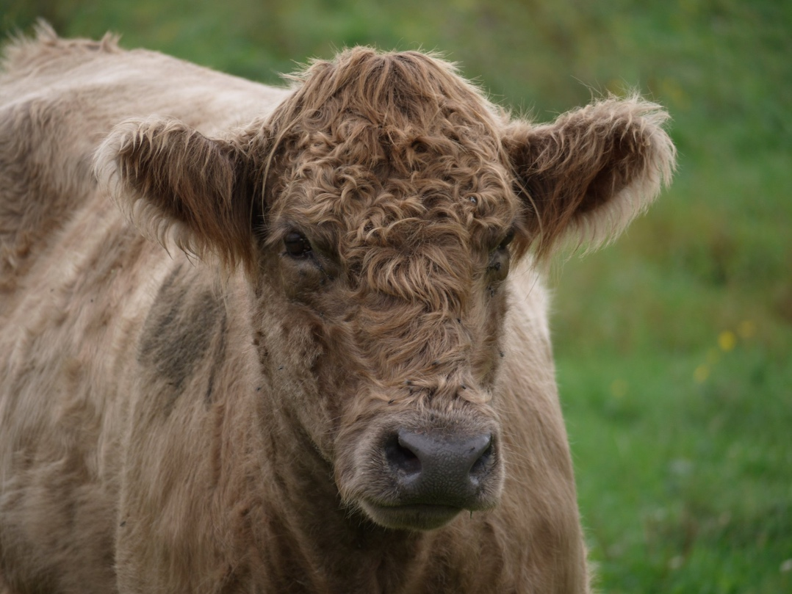
What do you call sleeping male cattle? Bulldozers
What do you get from pampered cows? Spoiled milk
Did you hear about the cow that tried to jump a barbwire fence? It was an udder disaster
What do you call a cow after she has given birth? Decaffeinated

