The Broadcaster ▪ Sept. 16, 2020 ▪ 715-432-6285 ▪ stoneyacrescsa@gmail.com ▪ www.stoneyacresfarm.net
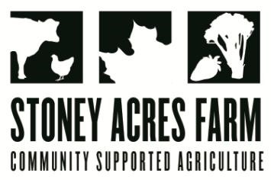
“What did the carrot say to the wheat? Lettuce rest, I'm feeling beet.
― Shel Silverstein

News from the Farm
CSA Week 16, 2020! My hoop house came! My Dad and I have started work assembling it; the frame is up, and I’m dreamin’ about all the possibilities! Hoop houses allow me to extend my season (I can plant spinach, and if we have a temperate winter, grow it all year round), and I can also baby certain crops (this is part of the reason we have such beautiful, perfect peppers this year). If you swing by the farm for a pizza, you can check out pepper house, tomato house, or basil house! On a less productive note, my naughty pigs escaped and discovered the winter squash! I corralled them back in, and we did an emergency squash harvest to make sure that that doesn’t happen again! I can’t blame the pigs too much for being enticed by the squash—they looks terrific and the crisp in the air has me looking forward to squash, too! These winter squash are definitely meant for eating, even though they are so pretty that folks often think they are decorative. They are in the acorn family, but even more tender and sweet. Katie and I like the roast them with a little olive oil and maple syrup (recipe below). Even naughtier than the pigs was a rogue skunk who greeted me in the pack shed this week! Thankfully he ambled away, and I escaped with nothing more than my own, natural musk. The kids are getting into the groove of being back in school, and when I need incentive to get them out the door and into the car, I offer to let them bring a kitten to drop off. Earl and Big Mike are getting used to the commute!
--Have a delicious week- Tony, Riley, Ted, & Maple
In Your Box
Tomatoes
Peppers
Bok Choy/Napa Cabbage
Spinach
Fennel
Broccoli
Beets
Carrots
Potatoes
Winter Squash

Next Week’s Best Guess: Tomatoes, peppers, leeks, bok choy, napa cabbage, cabbage, potatoes
Pizza specials of the Vegginald Vel-Johnson- Fennel, zucchini, broccoli, onions. Ben Franklin Soaking Food – Stoney sausage, peppers, caramelized onions, ajued oyster mushrooms. Blue Oyster Cult – Carr valley blue cheese, stoney sausage, ajued oyster mushrooms, garlic sauce Sweet Honey n’ the Bock – Bacon, chevre, heirloom tomatoes, honey, and fresh ground pepper. Scapegoat—Goat cheese from laclare farm, garlic scape pesto, flecked ham, and roasted garlic scapes in post. Charlie Behrens brats, sauerkraut, cheese curds Margherita—Fresh basil, heirloom tomatoes, fresh mozz, and basil pesto
Farm to Table Recipes Gleaned by Tony and Katie (and usually Heather Busig)
Shredded Beet Salad (from Earth, Food, and Fire):
Salad ingredients: 1 beet shredded, 1 carrot peeled and shredded, 1 apple cored and shredded, 1 cup chopped parsley, 1/2 cup rough chopped walnuts. For The Dressing: 1/2 cup olive oil, 1 tbsp apple cider vinegar, 1 lemon juiced and zested, 1tbsp honey or maple syrup., Salt, Pepper

Roast Delicata and Honey Boat Squash: 2-3 lbs delicata squash (about 2), 2 tablespoons olive oil, 2 tablespoons maple syrup, salt and pepper to taste. Instructions: Preheat the oven to 400 degrees. Halve the delicata squash lengthwise and remove the seeds (Tony doesn’t peel and the seeds are fine to eat). Cut the halves into 1/3 inch thick slices (no need to peel),mix together the olive oil, maple syrup, brown sugar, and salt and pepper to taste, Pour the olive oil mixture over the squash and toss to coat. Bake for 20-30 minutes or until squash is tender and starting to brown. Serve immediately. Terrific over a spinach salad. Also, Katie sometimes roasts with sliced onion and tops over a greens salad, too.
Food Delights from Shel Silverstein
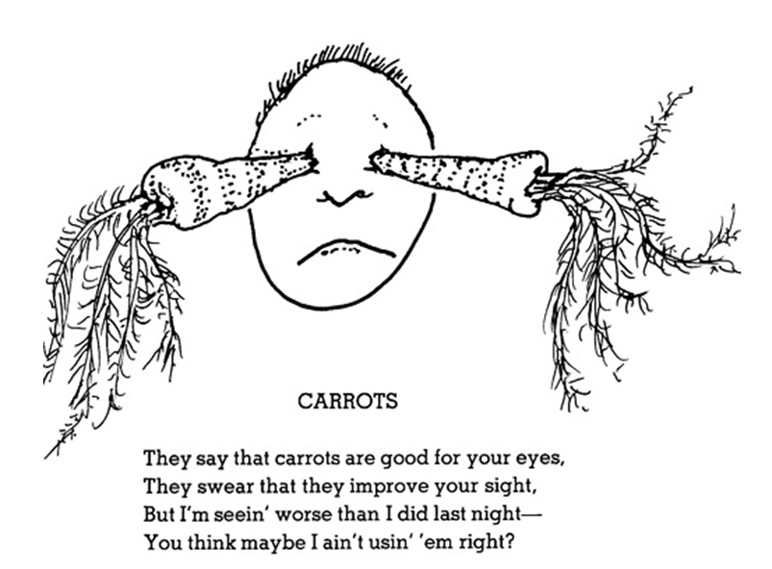
Vegetables
Eat a tomato and you'll turn red
(I don't think that's really so);
Eat a carrot and you'll turn orange
(Still and all, you never know);
Eat some spinach and you'll turn green
(I'm not saying that it's true
But that's what I heard, and so
I thought I'd pass it on to you).
Shel Silverstein

