The Broadcaster ▪ Sept. 23, 2020 ▪ 715-432-6285 ▪ stoneyacrescsa@gmail.com ▪ www.stoneyacresfarm.net
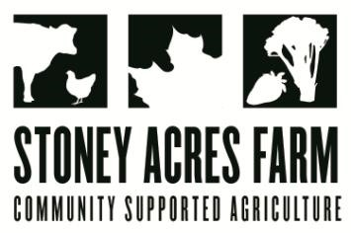
“When I shop for fruit & melons I like to hold a grape next to a cantaloupe & think of Earth next to Jupiter. Then I eat Earth.”
-- Neil deGrasse Tyson

News from the Farm
CSA Week 17, 2020! We have seen our first frost at Stoney Acres, which signals a time of transition in terms of what we are harvesting. Tomatoes are done for the season—disappointing news to my resident skunk who has been sneaking around for tomato scraps. We are starting to harvest more fall veggies, which are often made sweeter by the dip into cooler temperatures. This week, and for the next couple of weeks, we will be harvesting melons. Melon house was a success this year, and I think that our great weather all season long has yielded some really delicious and sweet fruit! Riley and I walked through the fields yesterday snacking on melons and it is a wonderful late September treat! The crew has started pulling up the first of the sweet potatoes, and while they won’t make it into the box this week, you can plan to see those in the next couple of weeks as well! The naughty pigs have abandoned hope in the delicata squash, and have set their sights on the spinach. Don’t worry, though, we got it harvested before they could feast too much! This has been an incredible pepper year, and you have peppers in your box again this week—I’m including an easy recipe for a chiles relleno inspired dish this week, which will be a decadent way to enjoy your poblano peppers. If you have time to stop by this weekend for pizza, we have an incredible lineup of specialty pizzas and on Saturday night we are featuring a polka band—the Hayes Boys Orchestra! Between our farm-brewed beer and the lederhosen, it’s sure to be a terrific, socially-distanced time! The back of the newsletter features the 2021 season CSA sign up—you’re welcome to mail this back to me or bring it to the market if you’re interested in another season of fresh-from-the-farm to you veggies!
--Have a delicious week- Tony, Riley, Ted, & Maple
In Your Box
Peppers
Poblano peppers
Leeks
Melons
Pumpkins
Celery
Broccoli
Carrots
Cheap Frills (salad mix)
Radishes

Next Week’s Best Guess: Sweet potatoes, peppers, leeks, bok choy, napa cabbage, cabbage, potatoes
Pizza specials of the Vegginald Vel-Johnson- Fennel, zucchini, broccoli, onions. Ben Franklin Soaking Food – Stoney sausage, peppers, caramelized onions, ajued oyster mushrooms. Peter Piper Picked a Peck of Pickled Peppers Pizza– Sausage, flecked ham, onions, pickled Hungarian hot wax peppers Samurai Delicatessen – Fried shishito peppers, sthitake mushroom, teriyaki marinated steak, fresh mozz, baby mizuna greens in post. Ramona the Pesto—Pesto base, flecked ham, heirloom tomatoes, roasted fenel, red peppers. First Taste of Fall, Saged squash sauce, flecked ham, onions, bleu cheese, roast honey boat squash. Charlie Berens—Saukeraut, cheese curds, brats, onions
Farm to Table Recipes Gleaned by Tony and Katie (and usually Heather Busig)
Chiles Rellenos Jose (from Asparagus to Zucchini):
Salad ingredients: Whole or halved poblano chiles, enough to cover a 7x13 inch pan, 1 lb. monteray jack cheese, cut into thin strips, 5 large eggs, ¼ cup flour, 1&1/4 C. milk, ½ t salt, ½ lb grated cheddar cheese, ½ tsp. paprika. Instructions: seed the chiles, slip strips of Monterey jack cheese inside. Beat eggs and gradually add flour, milk, and salt, arrange chiles in a well greased pan, sprinkle on the cheddar, pour on the egg mixture. Bake uncovered at 350 degrees for 45 minutes.

Pumpkin Tips: Store pumpkins in a cool, dry place. Pumpkins will last at room temperature for several weeks, and can last at 40-50 degrees for several months. Do not refrigerate unless cut open. Pumpkin may be cooked, pureed, and packed in air tight containers and frozen for use in soup or baked goods. Cooking Tips: Steam 1-2 inch chunks for 15-20 minutes. Boil 1-2 inch chunks in salted water, 8-10 minutes. Cut in half and bake cut-side down with a little water in a pan at 350 degrees for 40-50 miinutes. Pumpkin seeds are a terrific snack. Scoop out, rinse, pat dry, and put in a bowl with a little olive oil. Bake at 250 for 50-60 minutes, stirring once or twice. Sprinkle with salt and pepper, or trying a combination of spices that you enjoy!

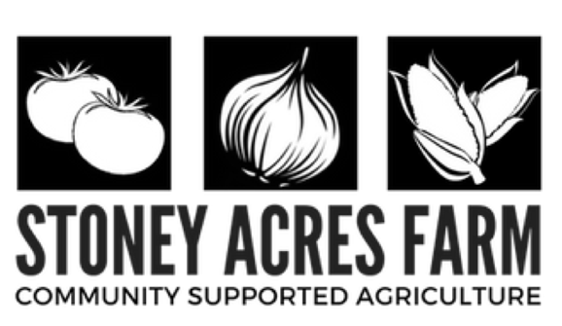
2021 CSA SIGN-UP FORM
715-432-6285 (call or text)
stoneyacrescsa@gmail.com
245728 Baldwin Creek Road, Athens, WI 54411

Member Information
If splitting a share, provide both contacts. Please note that we do not physically split the shares for you.

Household 1:
Name(s) ______________________________________ Phone ________________________________________ Email _________________________________________ Address ______________________________________ ______________________________________________
Household 2:
Name(s) ______________________________________ Phone ________________________________________ Email _________________________________________ Address ______________________________________ ______________________________________________

Share Options
Please check which share you would like to receive.

- FULL SHARE $550 (3/4 BUSHEL): Includes a box of produce larger than a paper grocery bag each week during the growing season. Farm events, u-pick, and site delivery also included. This is a good amount for a family or a couple who eat a lot of produce.

- SMALL FAMILY $450 (1/2 BUSHEL): Includes about 2/3'rds the amount of a full share each week during the growing season. Farm events, u-pick, and site delivery also included. This is a good amount for two people or a family that does not use many vegetables or wants to supplement other sources.

- SHARE A SHARE $_______: $25, $50, $100 or choose any amount you wish with subsidizing shares for low income families.

- COMMUNITY, WORKER or LOW INCOME: We offer a limited number of worker shares (4 hours weekly work in exchange for a full share), community shares (same as a full share, but with a full day of work commitment for a reduced rate of $500, and low income shares for families with subsidized shares. *Please note that you must contact us directly to be approved for one of these plans. We do offer payment plans if needed.

- MARKET SHARE $_________: You can purchase a market share to be used at the farm or the Wausau Farmer’s Market at a 5% discount for a $250 share, or 10% discount for a $500 share.

Pick Up Locations
- FARM ($25 OFF)
- ATHENS
- WAUSAU EAST
- WAUSAU WEST
- MERRILL
- MARSHFIELD

Member Agreement
I am responsible for pick of my box between 1 and 6 PM Thursdays - and understand that after that time the box may not be available. I will read the newsletter each week and understand that important updates are there, in print form or online. I understand that CSA's are based on the idea of shared risk and reward. In the event of severe weather or uncontrollable circumstances that a CSA box is not a guarantee while in times of bounty, more food may be provided.
. Please make check payable to Stoney Acres Farm and send to 245728 Baldwin Creek Road | Athens, WI 54411

