The Broadcaster ▪ October 7, 2020 ▪ 715-432-6285 ▪ stoneyacrescsa@gmail.com ▪ www.stoneyacresfarm.net
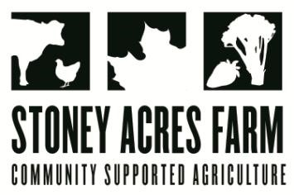

“Greet celeriac, the unsung frog prince of winter vegetables.”
--Jack Staub
News from the Farm
CSA Week 19, 2020! The Athens school district has gone virtual, and that means bonus time with Riley, Ted, and Maple this week. Having extra time with them has been a special treat. Besides playing lots of basketball, pop-a-shot, movies, and snuggles, we’ve done the usual farm chores together and a few extra projects, too. We’ve harvested apples, took the pig fence down, and did some hoop house work, too. We had a few other adventures, too. Yesterday I had one hundred baby chicks delivered earlier than expected; I had to put some harvesting on hold while I got them set up with a warm light and started building their coop in the barn. They are in the super-adorable chick stage right now, as opposed to the awkward adolescent or stately hen stage. The harvest has been going well; there are so many options for your box. The spinach was gaga this week and was perfect for your box. The Sugar dumpling squash are a fall treat—they are like an acorn squash, but sweeter and less stringy. I’m also putting celeriac in your box. It’s the weird, knobby thing that looks like a mandrake from the Harry Potter movies. It’s a celery root, and it has a mild celery flavor, and fancy restaurants like to include it in their mashed potatoes. It goes well in soups, and stews, too. To store, keep in your refrigerator crisper drawer; I have one in the bottom of my fridge from ‘84. –Have a delicious week-- Tony, Riley, Ted, & Maple, Earl the Cat, and 100 baby chickens

In Your Box
Peppers
Radishes
Carrots
Leeks
Onions
Celeriac
Beets
Spinach
Sugar Dumpling Squash
Brussel sprouts

Next Week’s Best Guess: Bok Choy, peppers, leeks, carrots, spinach, cabbage, potatoes
Pizza specials of the Week Vegginald Vel-Johnson- Fennel, zucchini, broccoli, onions. Ben Franklin Soaking Food – Stoney sausage, peppers, caramelized onions, ajued oyster mushrooms. Peter Piper Picked a Peck of Pickled Peppers Pizza– Sausage, flecked ham, onions, pickled Hungarian hot wax peppers Samurai Delicatessen – Fried shishito peppers, sthitake mushroom, teriyaki marinated steak, fresh mozz, baby mizuna greens in post. Ramona the Pesto—Pesto base, flecked ham, heirloom tomatoes, roasted fenel, red peppers. First Taste of Fall, Saged squash sauce, flecked ham, onions, bleu cheese, roast honey boat squash. Charlie Berens—Saukeraut, cheese curds, brats, onions
Farm to Table Recipes Gleaned by Tony and Katie
Celeriac Au Gratin (Asparagus to Zucchini): Ingredients: 2 large celeriac, peeled and sliced into 1/8 inch pieces. 2 TB butter, 1TB flour, 1 C chicken or veggie stock, salt & pepper to taste, 1 C grated Swiss or cheddar cheese. Simmer celeriac in water until tender, 15-20 minutes. Drain. In medium saucepan, melt butter. Add flour and cook until golden. Slowly whisk in stock and cook until thickened. Add salt and pepper. Place drained celeriac in shallow baking dish, top with sauce, sprinkle with cheese, and bake at 375 until golden, about 15 minutes.

Curried Celeriac and Carrot Puree (Asparagus to Zucchini): 1 lb. celeriac, peeled and chopped. 1 lb. carrots, peeled and chopped. 2 TB butter, 1 tsp grated ginger, 1 TB curry powder, 2 TB mango chutney (optional), ¼ heavy cream (or coconut milk), salt & pepper to taste. Boil celeriac and carrots until tender (about 20 min). Drain. Meanwhile, melt butter in small pan, add ginger and curry powder and sauté about 30 seconds. Puree cooked veggies, butter mixture, cream, chutney, salt, and pepper until smooth.
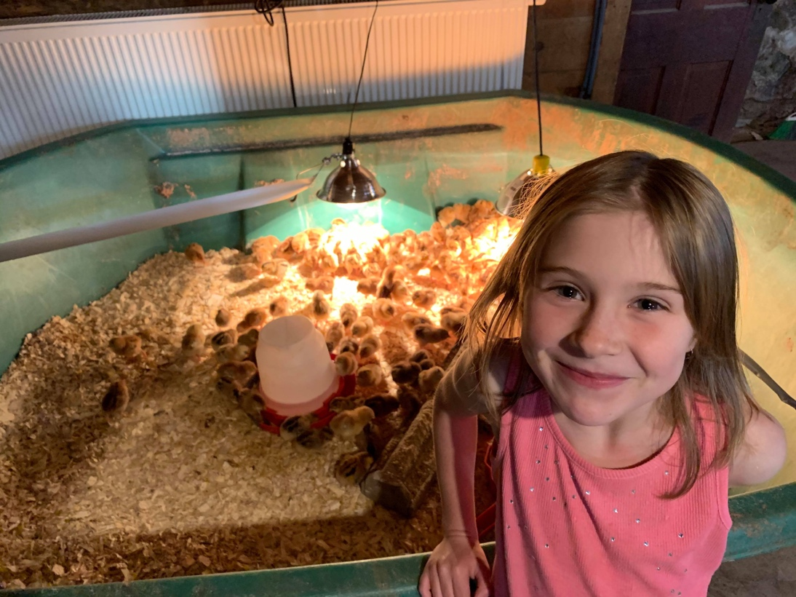
Q. Why did the rubber chicken cross the road?
A. She wanted to stretch her legs.
Q. Why did the Roman chicken cross the road?
A. She was afraid someone would Caesar!
Q. Why did the chicken cross the playground ?
A. To get to the other slide.
Q. Why did the rooster cross the road?
A. To cockadoodle dooo something.
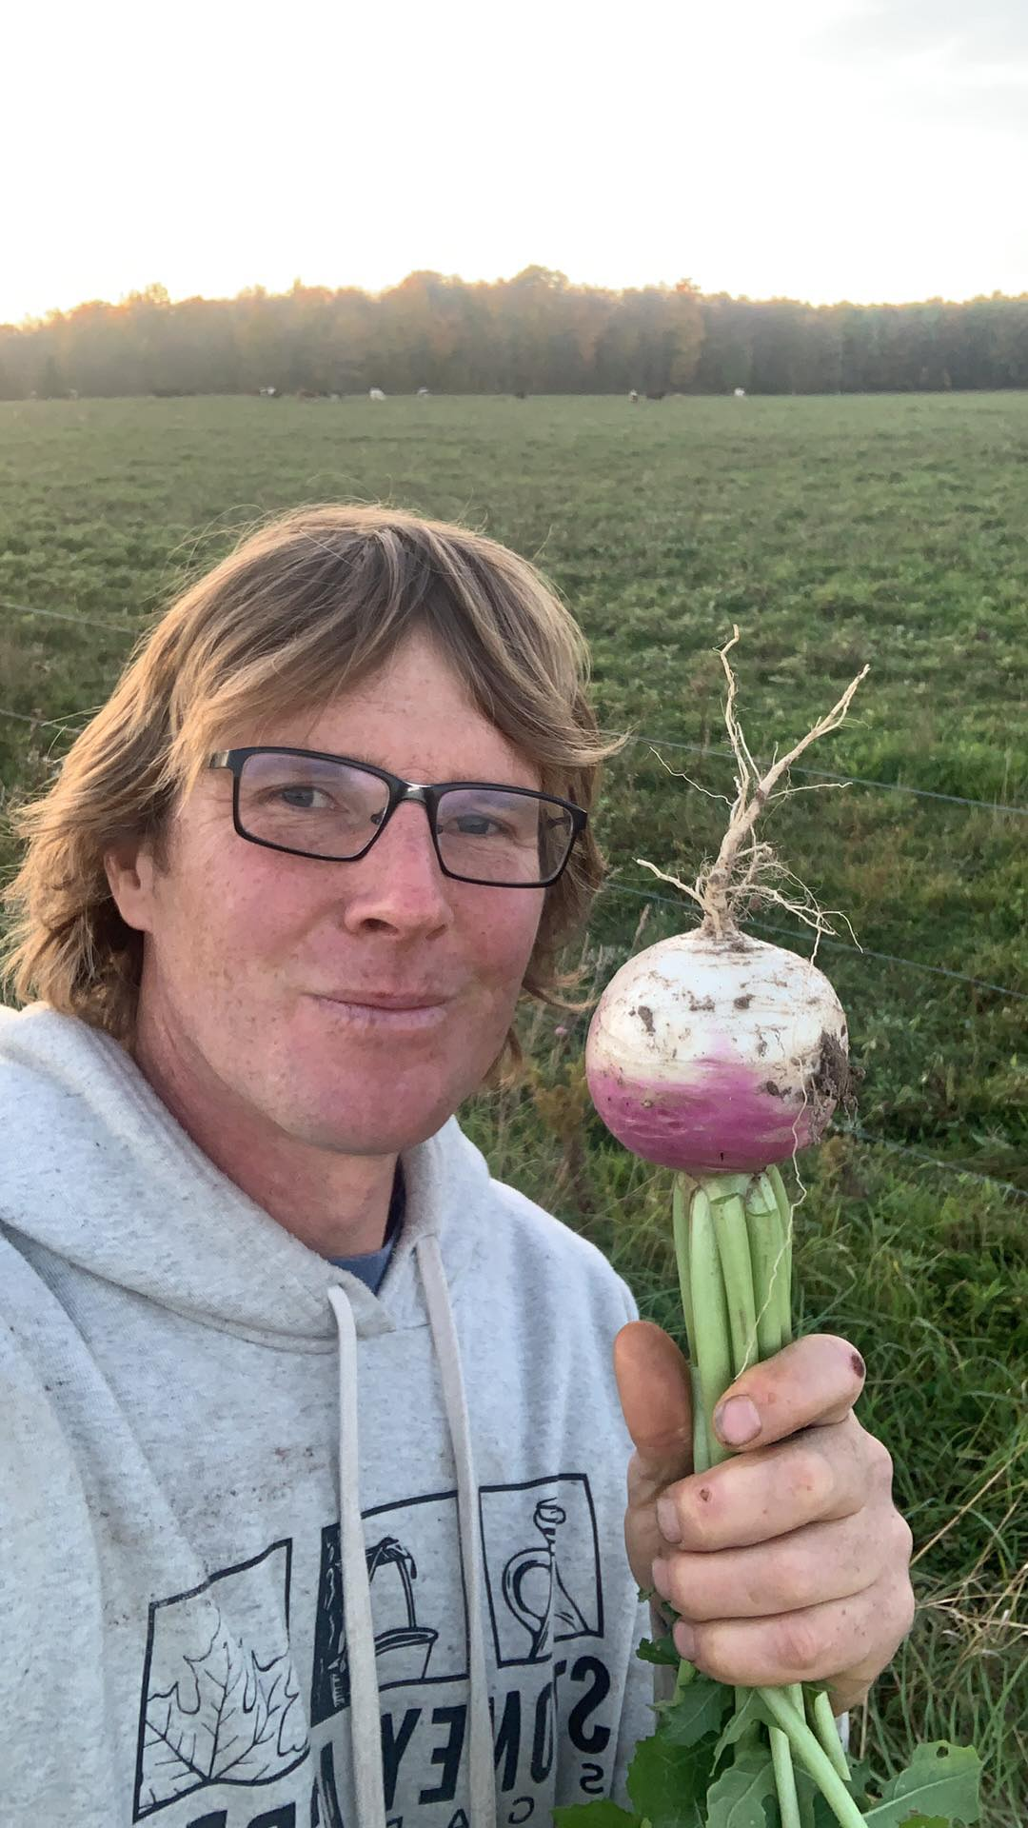
Q. Why did the dinosaur cross the road?
A. Because chickens hadn't evolved yet.
Q. Why did the turtle cross the road?
A. To get to the shell station.
Q. Why did the horse cross the road?
A. Because the chicken needed a day off.
Q. Why did the duck cross the road?
A. To prove he wasn't chicken!
Q. Why did the cow cross the road?
A. To get to the udder side!
Q. Why did the chickens cross the road?
A. Someone told them it was an egg-cellent idea.

Q. Why did the potato run across the road?
A. So it wouldn’t get mashed

Q. Why did the chicken stop crossing the road?
A. It got tired of the jokes.

