The Broadcaster ▪ July 22, 2020 ▪ 715-432-6285 ▪ stoneyacrescsa@gmail.com ▪ www.stoneyacresfarm.net
“’What are those bulb things you're slicing?’ ‘You've never seen fennel? It looks like celery and tastes like licorice.’" -- Ken Jennings

News from the Farm
CSA Week 8, 2020! We are in the swing of summer! We have spent a lot of time harvesting a beautiful bounty of fennel, kohlrabi, basil, carrots, and shitake mushrooms, among other crops! The theme of this week’s newsletter is going to be fennel! I use a fennel in several of my pizzas, so I grow a lot of it. I posted a picture of my fennel harvest on social media, and a lot of folks have been asking about how to use it. I’ll give you a few options for your fennel this week. Being part of a CSA has a lot of benefits, but one of the really exciting parts of joining a CSA is that it can, for some people, introduce them to new foods that they may not have tried or cooked before. I want to support you in your food adventure! If you aren’t sure what something is, or how to use it, just ask! A lot of people come up to me at the farmer’s market and ask what a particular vegetable is, or how to use something—that is part of being a good, versatile foodie! Besides a bounty of fennel, there is a lot of big news from the farm. The old floor from the barn is 100% gone! The Margherita pizza is back on the menu! There is a litter of kittens living in my basement! And perhaps the biggest and most exciting item of news from the farm is that Maple learned how to ride a bike this week! She is officially a card-carrying big-kid! She rode her bike seven miles the other day! I couldn’t be prouder of her! Have a delicious week- Tony, Riley, Ted, Maple

In Your Box
Cucumber
Zucchini
Carrots
Basil
Shiitake
Broccoli
Fennel
Kohlrabi
Scapes
Blueberries (fulls)

Next Week’s Best Guess: Carrots Fennel Cuc Zucchini Broccoli Basil Celery Tomatoes
Pizza specials of the Vegginald Vel-Johnson- Charred kale, roasted fennel, roasted cherry tomatoes, garlic sauce. Ben Franklin Soaking Food – Stoney sausage, peppers, caramelized onions, ajued oyster mushrooms. Blue Oyster Cult – Carr valley blue cheese, stoney sausage, ajued oyster mushrooms, garlic sauce Charred Chard – Flecked ham, roasted cherry tomatoes, roasted fennel, charred chard. Scapegoat—Goat cheese from laclare farm, garlic scape pesto, flecked ham, and roasted garlic scapes in post. Holy Shitake—Sausage, shitake mushrooms, roasted fennel, parm form harmony dairy in post. . Margherita—Fresh basil, heirloom tomatoes, fresh mozz, and basil pesto
Farm to Table Recipes Gleaned by Tony and Katie
Let’s make friends with fennel! Katie here—don’t tell Tony this, but I used to give away my fennel when I got it in my share because I didn’t like it. And it was weird. And I didn’t know what to do with it. And someone would always be picking up their share at the same time of me and say “WHAAAT? You don’t want your fennel? I’ll take it!” Years later, I can confidently say that I have eaten enough fennel that I actually like it. There are so many different ways to prepare it, that you can find one that suits your appetite. My favorite way to eat fennel is to have the bulb roasted or grilled. Tony also likes the bulb roasted, best. Maple’s favorite way to eat fennel is to have it chopped into a cucumber salad (add the fronds chopped into last week’s cucumber salad).

Fennel, Celery, and Apple Slaw (From Epicurious):
INGREDIENTS: Dressing: 3 tablespoons extra-virgin olive oil, 2 1/2 tablespoons apple cider vinegar, 1 1/2 tablespoons coarsely chopped fresh tarragon, 2 teaspoons fresh lemon juice, 1/4 teaspoon sugar. SALAD: celery stalks, thinly sliced diagonally, plus 1/4 cup loosely packed celery leaves, 2 small fennel bulbs, thinly sliced crosswise, plus 1 tablespoon chopped fennel fronds, 1 firm, crisp apple (such as Pink Lady, Gala, or Granny Smith), julienned, Kosher salt and freshly ground black pepper
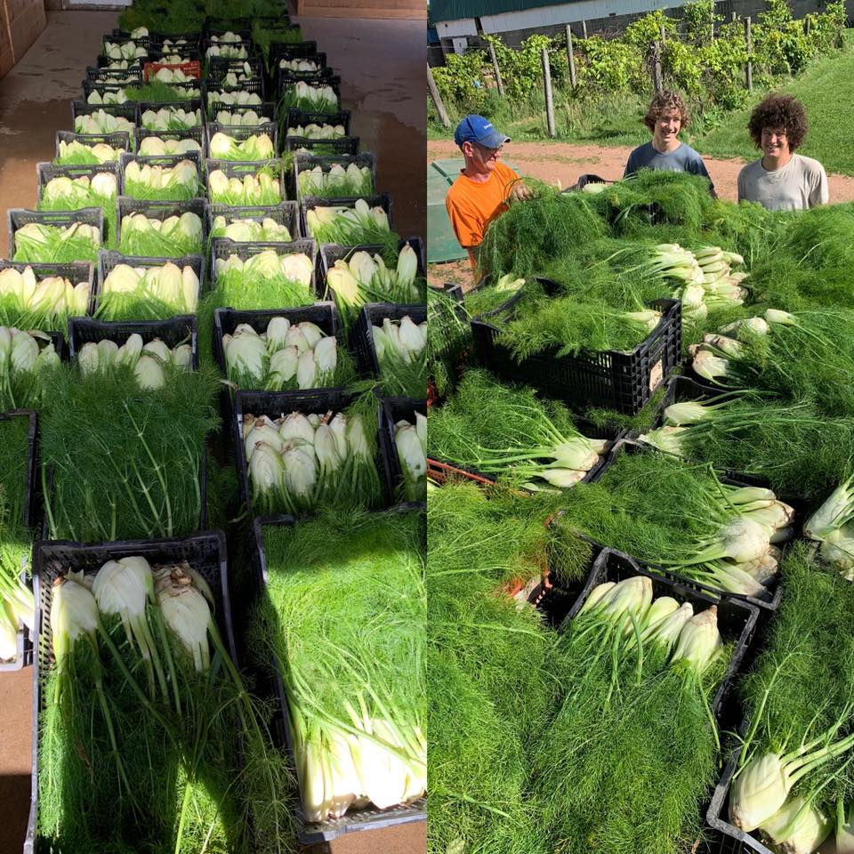
Roasted Fennel:

4 tablespoons olive oil
4 fennel bulbs, cut horizontally into 1/3-inch thick slices, fronds reserved
Salt and freshly ground black pepper
1/3 cup freshly grated parmesan
Preheat the oven to 375. Lightly oil the bottom of a 13 by 9 by 2-inch glass baking dish. Arrange the fennel in the dish. Sprinkle with salt and pepper, then with the Parmesan. Drizzle with the oil. Bake until the fennel is fork-tender and the top is golden brown, about 45 minutes. Chop enough fennel fronds to equal 2 teaspoons, then sprinkle over the roasted fennel

Fennel Gratin instructions: Preheat oven to 375
Remove the stalks from each fennel bulb and discard. Cut the bulbs in half lengthwise through the core. Remove most (but not all) of the core by cutting a V-shaped wedge, leaving the wedges intact. Cut each piece into 2, 3, or 4 wedges, depending on the size of the bulb. Arrange the wedges, cut side up, in a gratin dish just large enough to hold them snugly in a single layer. Pour the chicken stock and wine over the fennel, then sprinkle with 2 teaspoons of salt and ¾ teaspoon of pepper. Dot with the diced butter. Cover the dish tightly with aluminum foil and bake for 35 to 45 minutes, until the fennel is tender. Remove from the oven and raise the oven temperature to 425 degrees.
Meanwhile, make the topping. Combine the melted butter, panko, Parmesan, parsley, zest, 1 teaspoon salt, and ½ teaspoon pepper. Sprinkle evenly on top and return to the oven. Bake uncovered for 30 minutes, until the topping is browned. Serve hot or warm.

Fennel Gratin (from Ina Garten)
- 3 medium fennel bulbs
- 1/2 cup chicken stock, preferably homemade
- 1/3 cup dry white wine
- Kosher salt and freshly ground black pepper
- 2 tablespoons unsalted butter, diced
- 3 tablespoons unsalted butter, melted
- 3/4 cup panko (Japanese bread flakes)
- 1 cup freshly grated Parmesan cheese
- 1 tablespoon minced fresh flat-leaf parsley
- 1½ teaspoons grated lemon zest

Fennel, Bean, and Pasta Salad (from A-Z): Fennel bulbs, leafy tops removed and reserved, 1 small onion, olive oil, 1 28 oz can of kidney beans, drained, 2-3 cups of cooked pasta. 1 tsp of lemon pepper. Thinly slice fennel and onion, sauté in olive oil. Chop reserved tops and add to cooked mixture with remaining ingredients. Serve chilled.
Easy Fennel Soup (from Allrecipes): ¼ cup butter, 5 fennel bulbs fennel bulbs, trimmed and quartered, 1 (32 fluid ounce) container vegetable broth, 1 pinch salt and pepper to taste. Melt the butter in a large skillet over medium heat. Add the quartered fennel bulbs; cook and stir until golden brown, about 10 minutes. Pour in the broth, and simmer until fennel is tender, about 15 more minutes. Ladle into soup bowls, and season with salt and pepper.

