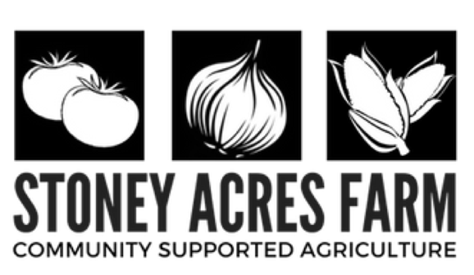
CSA SIGN-UP FORM
715-432-6285 (call or text)
stoneyacrescsa@gmail.com
245728 Baldwin Creek Road, Athens, WI 54411

Member Information
If splitting a share, provide both contacts. Please note that we do not physically split the shares for you.

Household 1:
Name(s) ______________________________________ Phone ________________________________________ Email _________________________________________ Address ______________________________________ ______________________________________________
Household 2:
Name(s) ______________________________________ Phone ________________________________________ Email _________________________________________ Address ______________________________________ ______________________________________________

Share Options
Please check which share you would like to receive.

- FULL SHARE $550 (3/4 BUSHEL): Includes a box of produce larger than a paper grocery bag each week during the growing season. Farm events, u-pick, and site delivery also included. This is a good amount for a family or a couple who eat a lot of produce.

- SMALL FAMILY $450 (1/2 BUSHEL): Includes about 2/3'rds the amount of a full share each week during the growing season. Farm events, u-pick, and site delivery also included. This is a good amount for two people or a family that does not use many vegetables or wants to supplement other sources.

- SHARE A SHARE $_______: $25, $50, $100 or choose any amount you wish with subsidizing shares for low income families.

- COMMUNITY, WORKER or LOW INCOME: We offer a limited number of worker shares (4 hours weekly work in exchange for a full share), community shares (same as a full share, but with a full day of work commitment for a reduced rate of $500, and low income shares for families with subsidized shares. *Please note that you must contact us directly to be approved for one of these plans. We do offer payment plans if needed.

- MARKET SHARE $_________: You can purchase a market share to be used at the farm or the Wausau Farmer’s Market at a 5% discount for a $250 share, or 10% discount for a $500 share.

Pick Up Locations
- FARM ($25 OFF)
- ATHENS
- WAUSAU EAST
- WAUSAU WEST
- MERRILL
- MARSHFIELD
Member Agreement
I am responsible for pick of my box between 1 and 6 PM Thursdays - and understand that after that time the box may not be available. I will read the newsletter each week and understand that important updates are there, in print form or online. I understand that CSA's are based on the idea of shared risk and reward. In the event of severe weather or uncontrollable circumstances that a CSA box is not a guarantee while in times of bounty, more food may be provided.

Please make check payable to Stoney Acres Farm and send to 245728 Baldwin Creek Road | Athens, WI 54411

